Database Management System

Done by: Mohammed Mahmood Al-Fahdi

GitHub account: mohammedFahdi

Table of Contents

**Flat File Systems vs. Relational Databases:** 3

**DBMS Advantages – Mind Map** 5

**Roles in a Database System** 6

1. DBA, or database administrator 6

2. Analysts of Systems 6

3. Designers of databases 6

4. Final Users 6

**Types of Databases** 7

1. Hierarchical Databases 7

2. Databases on networks 7

3. Databases that are object-oriented 7

**Cloud Storage and Databases** 8

**References**: 9

# **Flat File Systems vs. Relational Databases:**

Consider a spreadsheet that has columns and rows. This is the general style of a flat file. A single record is represented by each row, and a particular field or data point inside that record is reflected by each column. For example, customer ID, name, address, phone number, and email address might all be listed in columns in a flat file data storage system for client data. (Staff, 2024)  
The simplicity of flat file data storage makes it popular. It requires no technical knowledge and is simple to set up and use. Flat file data storage can have certain drawbacks, though. As data volume increases, handling and modifying data in a flat file can become challenging. Data redundancy is another issue that flat files face, which results in inconsistencies and inefficiencies.

Relational databases offer a more complex method to data storage. Relational databases hold data in numerous tables as compared to flat files. Relationships are used to connect these tables, which improves data organization and gets rid of redundant information. Along with data variables, they may also refer to and check data constants.   
Effective data retrieval and manipulation are made possible by this relational framework. Even if the information is dispersed among many tables, you may still quickly query the database to find specific information.

A lot of businesses are launching new websites. Because relational databases allow you to store data from several branches in distinct tables inside the same database, users may compare the branch data for reporting purposes and rapidly query the whole database.   
The best option for managing and storing complicated data is a relational database. They are perfect for companies that need to store and analyze a lot of data, such product catalogues, financial records, and customer information.

Your needs will decide whether to use a relational database or flat file data storage. Here are some points to think about:

1. Amount of data: If you are working with a little amount of data, flat file data storage may be adequate. However, a relational database is a preferable choice if you expect your data to increase dramatically over time. This is particularly relevant for data integrity as it makes data more dependable by reducing data duplication.
2. Data complexity: If your data is straightforward and has few connections between various data points, flat file data storage may be an option. However, a relational database is necessary to manage your stock levels, the goods that are selling well, and the location of your stock when dealing with complicated data that has many interrelated aspects.
3. Collaboration and data sharing: If several people need to view and edit the data, a relational database is the ideal choice.

# **DBMS Advantages – Mind Map**

(GeeksforGeeks, 2025)

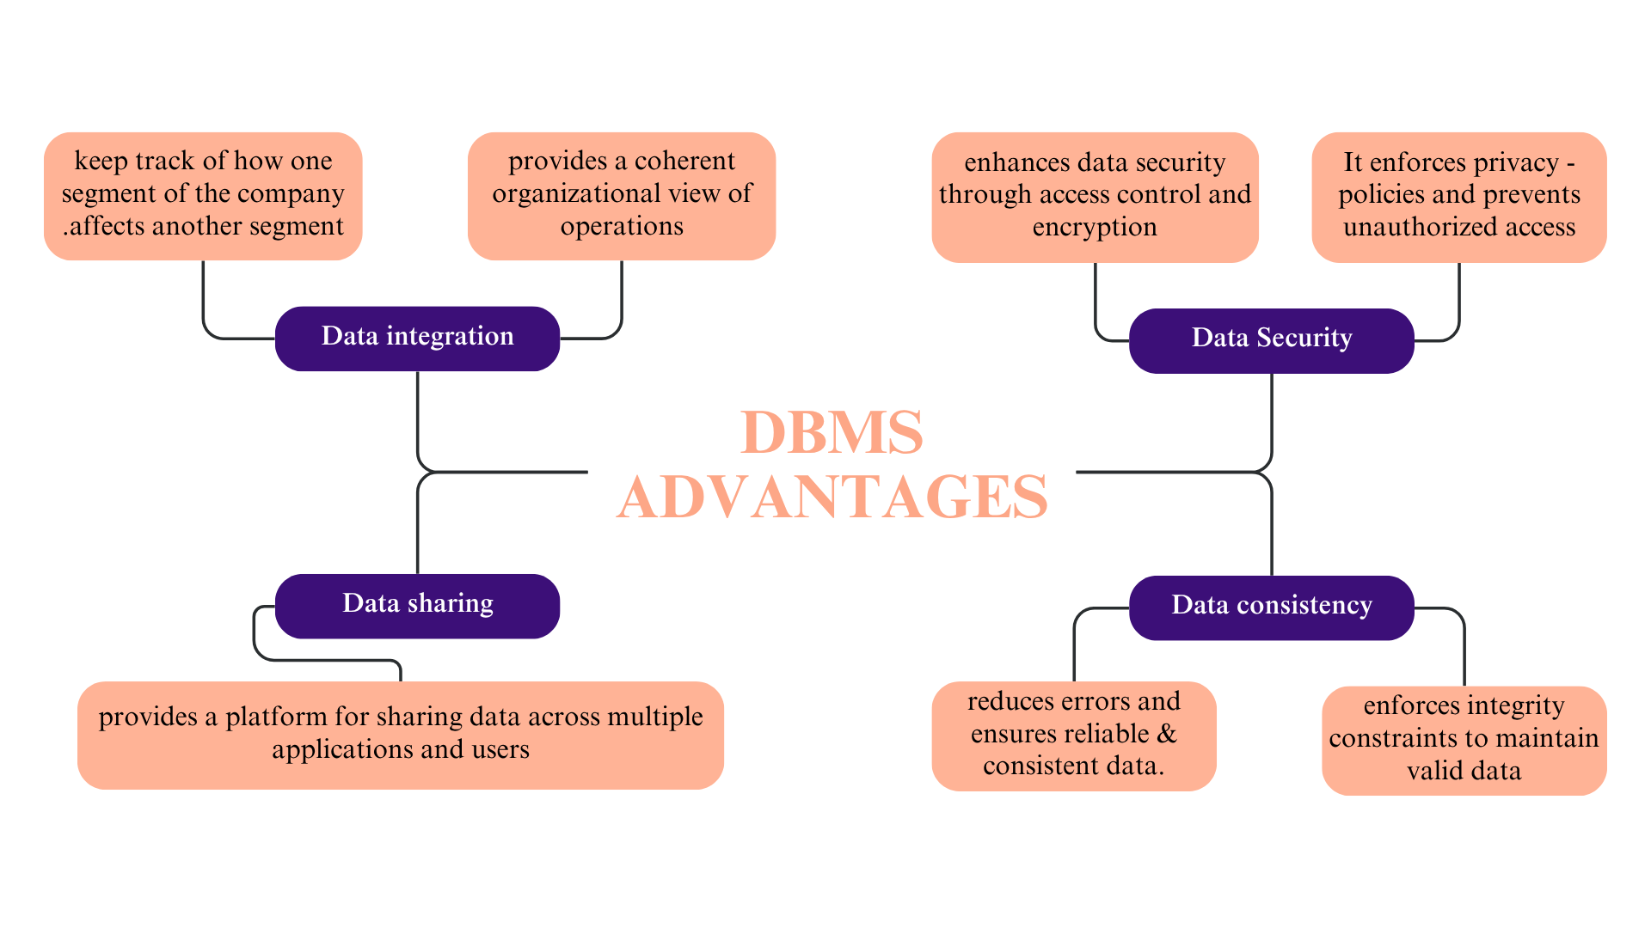

# **Roles in a Database System**

Different Types of Database Users in DBMS (HeroVired Editorial Team, 2025)

1. DBA, or database administrator   
   in every DBMS setting, a database administrator plays a crucial role. Maintaining the database's high performance and overall health is often the job of DBAs. They ensure that the database will operate correctly and be protected.
2. Analysts of Systems   
   System analysts sit between technical support personnel and end users. They are able to transform customer expectations into technical requirements for database designers and programmers.
3. Designers of databases   
   Database designers play a major role in developing the fundamental framework of every database management system. They are in charge of figuring out how the database's structural architecture complies with different requirements and operates at its best. To make sure the database satisfies the organization's needs, they must do a great deal of planning and designing.
4. Final Users   
   those that interact with the database without having a thorough understanding of its internal operations are known as end users. To carry out their duties, they depend on pre-made apps. These DBMS database users are usually intent on finishing particular, frequently repeated activities.

# **Types of Databases**

According to GeeksforGeeks (2025b). Databases can be categorized according to their intended use, storage techniques, structure, and use. Knowing these kinds will enable us to select the ideal database for our needs.

1. Hierarchical Databases  
each parent record in a hierarchical database may contain several child records, arranging the data in a tree-like structure. When data is organized in levels or ranks and follows a predetermined hierarchical structure, this approach performs well. For instance, although "Departments" and "Administration" are separate organizations, they are at lesser levels of a university, with "University" at the top.

2. Databases on networks   
Building on the hierarchical paradigm, network databases enable child records to be connected to several parent records, resulting in a structure of interlinked data that resembles a web. This leads to a more adaptable structure - often called a graph model -where items may be linked in a variety of ways. Take club students, for instance. A student may join more than one club, and a club may have more than one student in a university database.

3. Databases that are object-oriented   
the foundation of object-oriented databases is object-oriented programming (OOP), which stores data as objects. These objects are readily accessed and modified because they have attributes (data) and methods (functions). Multimedia, images, and big files are examples of complicated data structures that these systems are made to manage.

# **Cloud Storage and Databases**

Databases and cloud storage are separate but related parts of cloud computing. A scalable, all-purpose location for storing all kinds of data, including files, photos, and videos, is offered by cloud storage. Contrarily, databases are specialized systems for maintaining, organizing, and querying structured data; they frequently include details about records and their connections. Although the files required by a database can be stored in cloud storage, the database itself offers the organization and resources necessary to effectively access and work with that data.   
What Cloud Storage Is For: mostly for keeping vast amounts of unstructured or semi-structured data, such as backups, archives, media files, and papers. Cloud storage accessibility is usually, data kept in cloud storage may be accessed online. However, the goal of databases is to store, manage, and retrieve organized data; frequently, this is accomplished by utilizing a query language.   
Cloud databases, which are database management systems hosted and accessible through the cloud, combine the advantages of cloud computing, such as scalability and lower costs, with the capabilities of traditional databases.

# **References**:

GeeksforGeeks. (2025a, July 12). *Advantages of database management System*. GeeksforGeeks. <https://www.geeksforgeeks.org/dbms/advantages-of-database-management-system/>

GeeksforGeeks. (2025b, July 12). *Types of databases*. GeeksforGeeks. <https://www.geeksforgeeks.org/dbms/types-of-databases/>

HeroVired Editorial Team. (2025, January 30). *Different types of database users in DBMS explained*. Hero Vired. <https://herovired.com/learning-hub/topics/database-users-in-dbms/>

Staff, E. (2024, May 13). *Flat File vs. Relational Databases: Securing LBM Customer Data*. ECI Software Solutions. <https://www.ecisolutions.com/blog/building-supply/the-difference-between-flat-file-and-relational-data/>